**Bishop’s University**

**Computer Vision / Image Analysis – Winter 2019**

**Final Project**

1. **Assignment**
2. Group member: Yukuan Hao, Liming Yang, Liang Gu, Rouwen Mao
3. assignment: K-means image segmentation
4. **brief problem definition**
5. create K-means C++ program and using color, grayscale, location, and texture as feature
6. create Meng-Hee-Heng variant C++ program and using color, grayscale, location, and texture as feature
7. **summary of choices made for the solution**

In this project, we use OpenCV 4.0 library to read an input image and use some function in OpenCV library :

1) Read and write pixel values(img.ptr() and img.at())

2) Create a blank image to store the result image (Mat class)

3) Read and write images(imread(), imshow())

4) Determine whether the image reading success(img.data)

In addition, we create 10 functions by ourselves for image segmentation, there has 4 functions used for basic K-means image segmentation based on different feature(color, grayscale, and location), 4 functions used for Meng-Hee-Heng variant image segmentation based on different feature(color, grayscale, and location), 2 functions used to extract image texture(Law’s texture method, and LBP method)

We use those function to process the input image and compare the result, finally we get the result:

1. Basic kmeans with color or grayscale usually get good result, because different object has different grayscale or color value.
2. Basic kmeans with location can not get good result if it has the same weight as grayscale or color, so we decrease the weight of location, finally we get similar result with regular K-means method.
3. Meng-Hee-Heng’s variant with color or grayscale method can automatically create new cluster but it will cost a long time to process, so we set a parameter to limit the maximum number of clusters, the result is the same as basic K-means with color or grayscale method.
4. Meng-Hee-Heng’s variant with location is similar with Meng-Hee-Heng’s variant with color or grayscale method, we also decrease the weight of location, and the result is good.
5. We also create LBP(Local Binary Partition) method to extract the texture feature, but we can only get a clear result in the center of image and unclear result in edge of image.
6. At last, we create Law’s texture method, but this method can not give us a good texture result of image, because the image needs to preprocess, and it needs to subtract the average pixel in neighbor, so sometime we get a negative value, and the mask can give us some pixel out of bound. There are some details in section F.
7. **Segmentation results**

There are the results:

1.star.ppm

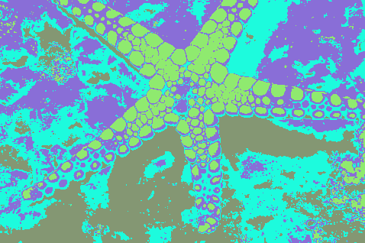K=4

K=5

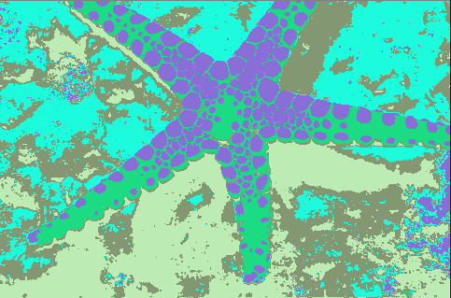

K=6

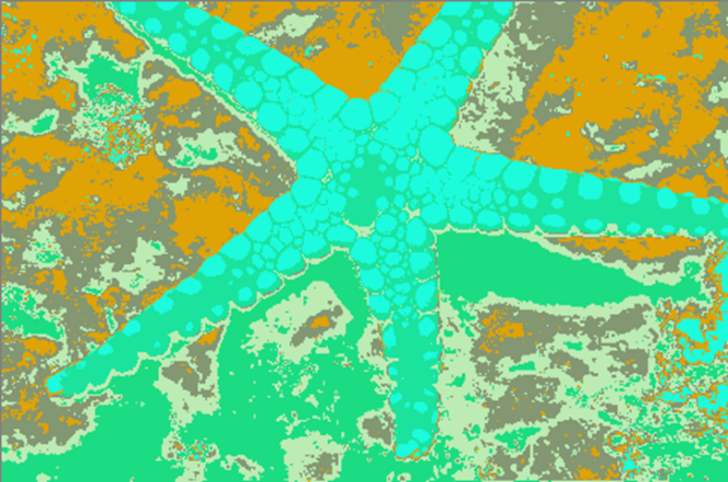

(b) Basic kmeans with color and location

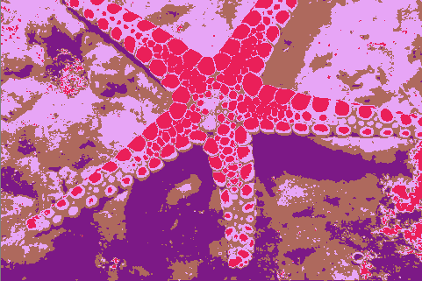K=4

K=5

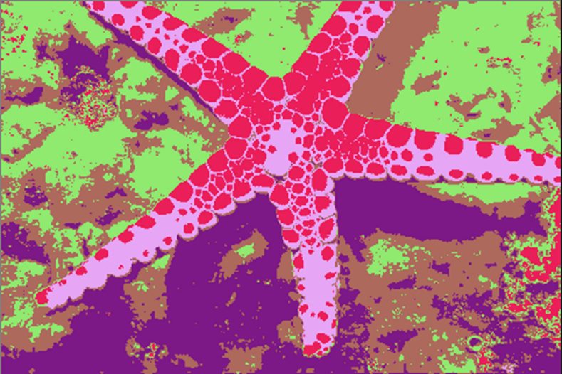

K=6

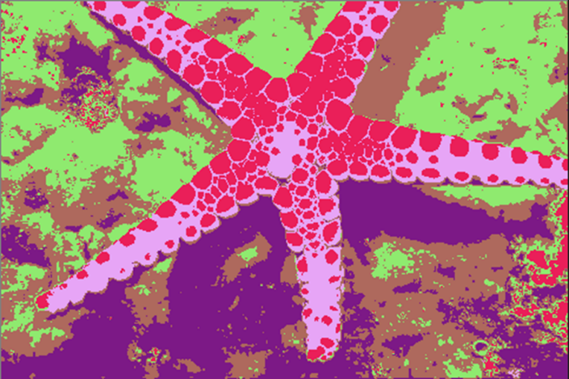

(C) Men Hee Heng’s variant with color

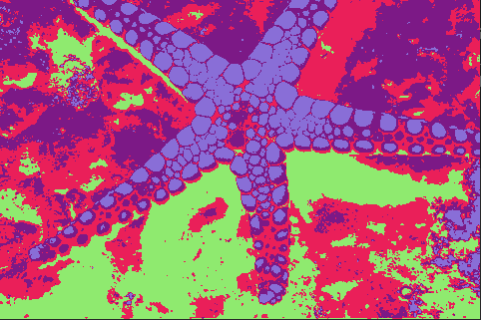K=4

K=5

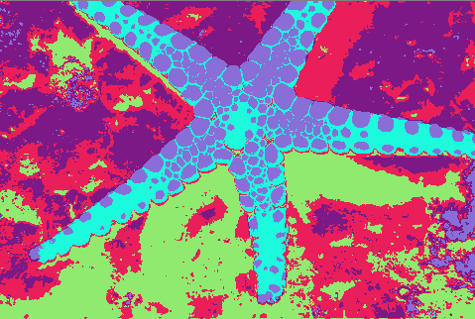

K=6

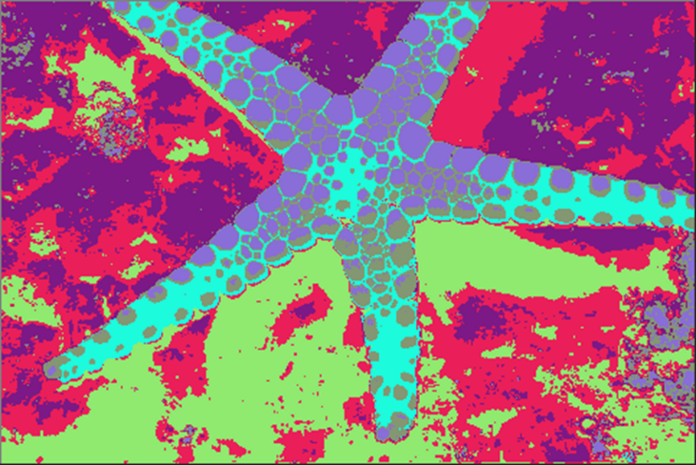

(d) Meng Hee Heng’s variant with color and location

K=4

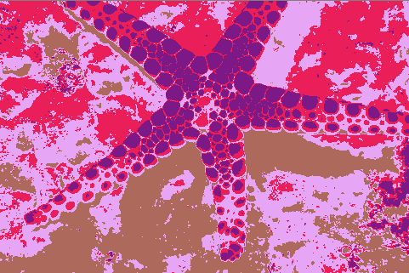

K=5

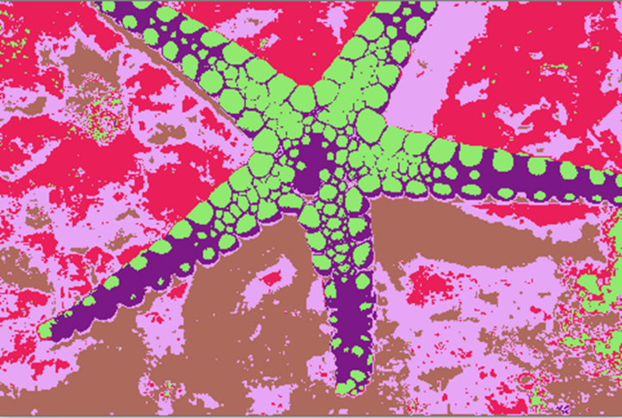

K=6

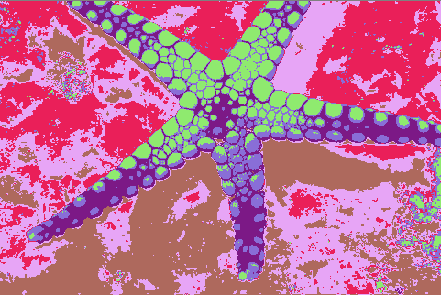

2. brain.pgm

1. Basic kmeans with grayscale

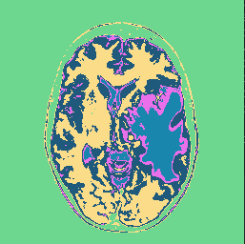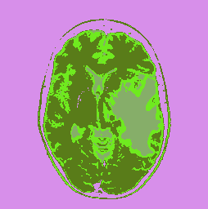K=4 K=5

1. Basic kmeans with grayscale and location

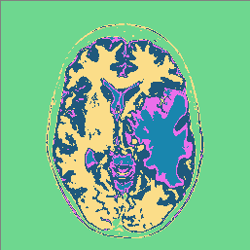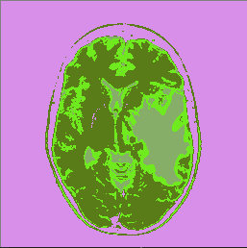K=4 K=5

1. Meng Hee Heng’s variant with grayscale

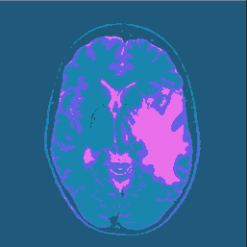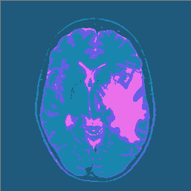K=4 K=5

1. Meng Hee Heng’s variant with grayscale and location

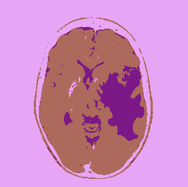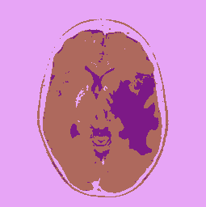K=4 K=5

3.lena.ppm

(a) Basic kmeans with color

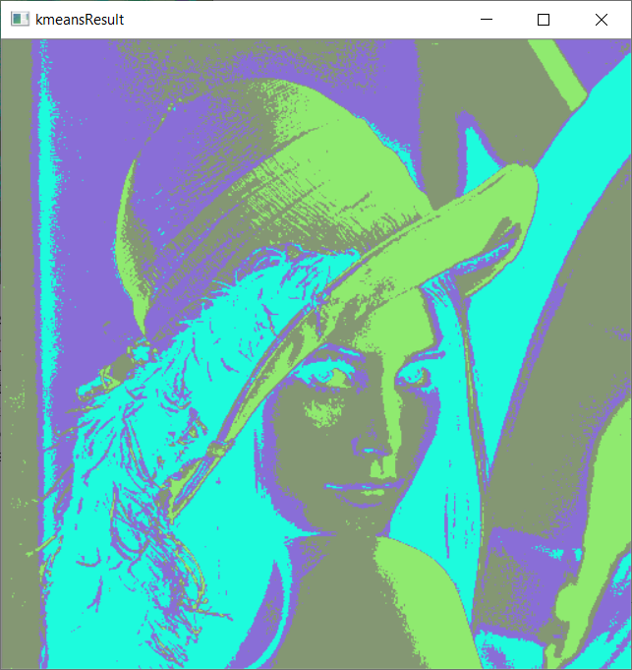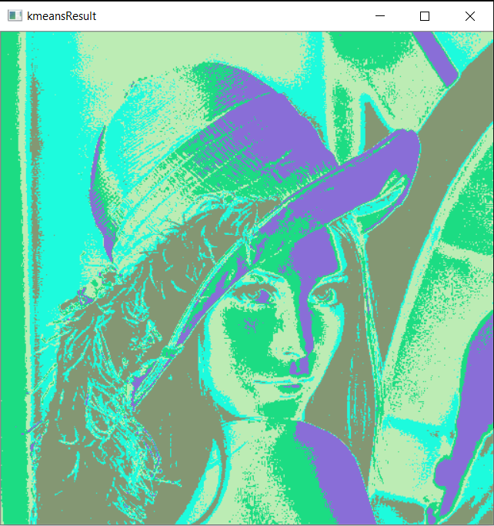

K=4 K=5

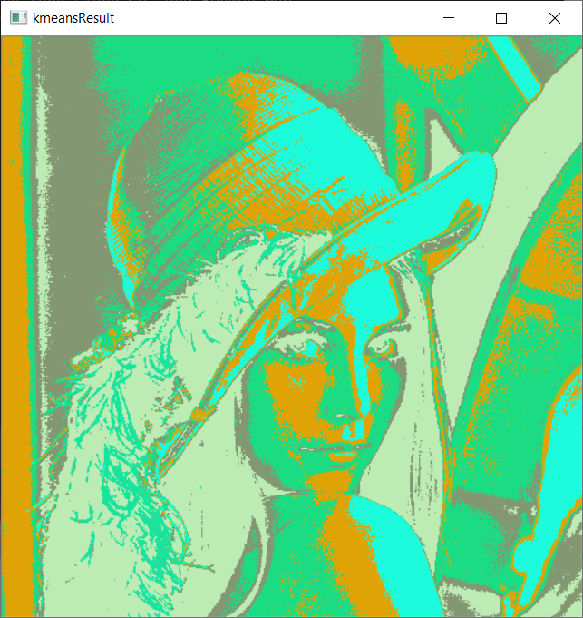

K=6

(b) Basic kmeans with color and location

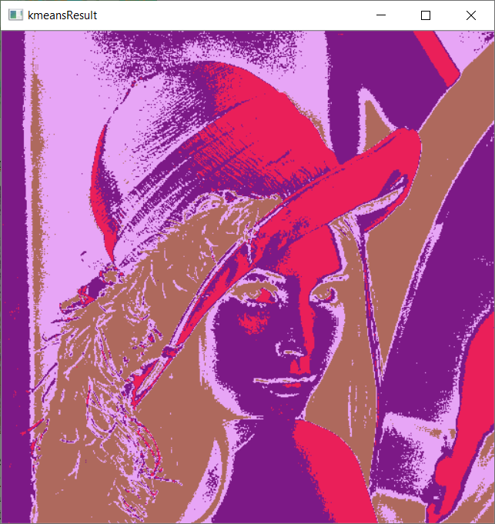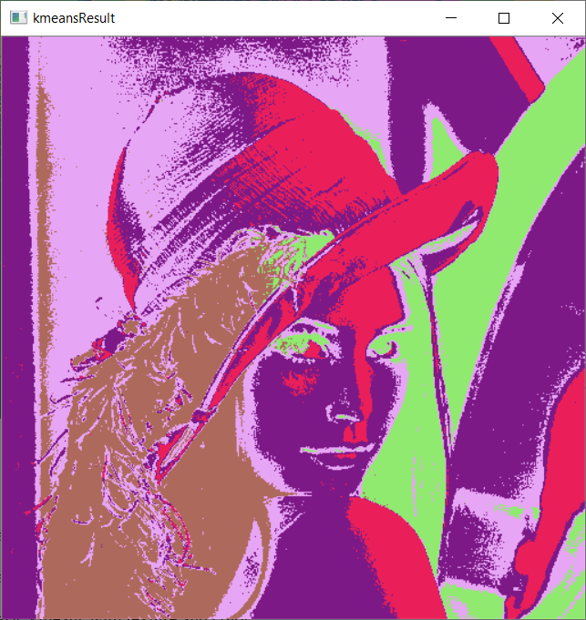

K=4 K=5

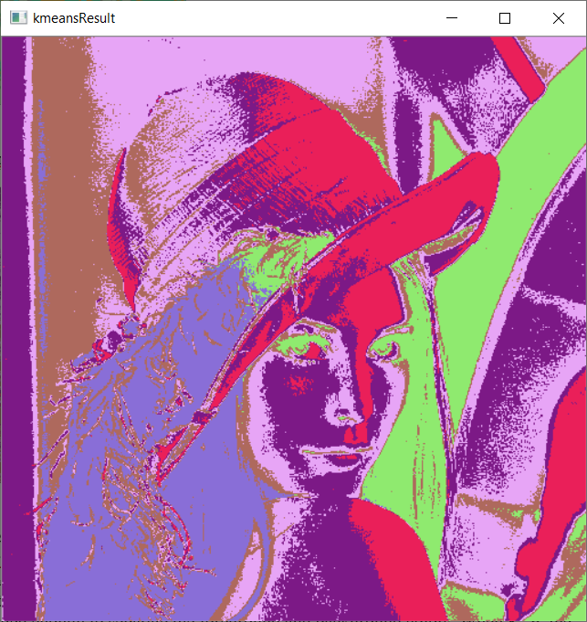

K=6

(C) Men Hee Heng’s variant with color

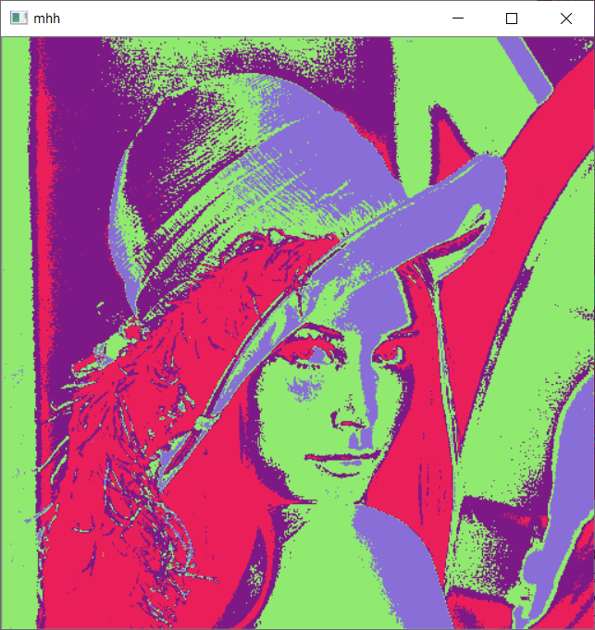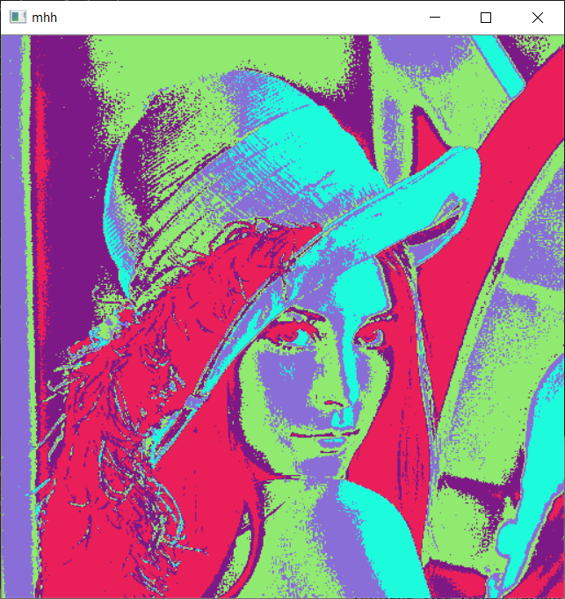

K=4 K=5

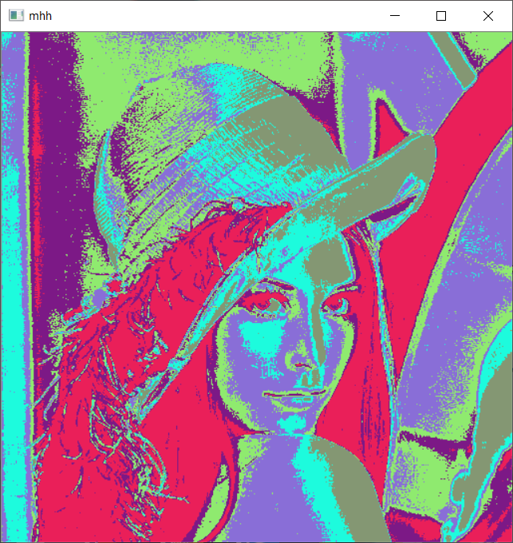

K=6

(d) Meng Hee Heng’s variant with color and location

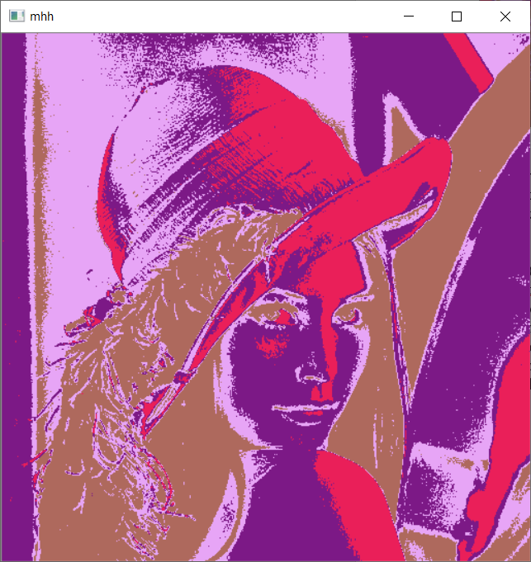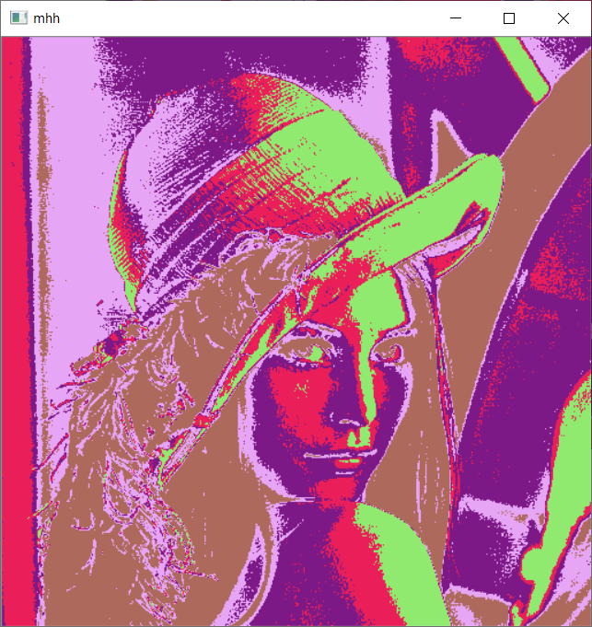

K=4 K=5

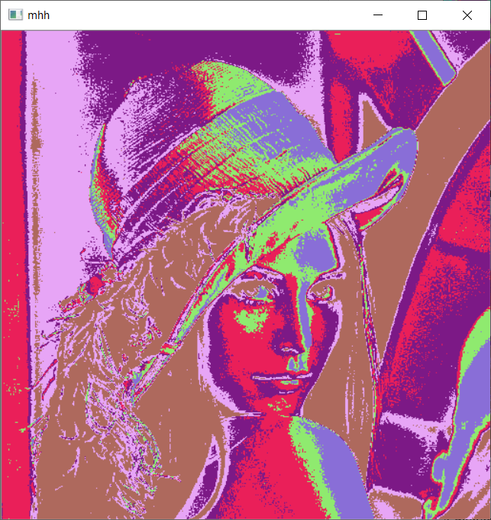  
K=6

4.bacteria.pgm

(a)Basic kmeans with grayscale

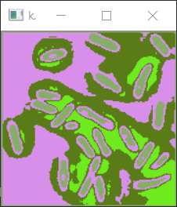 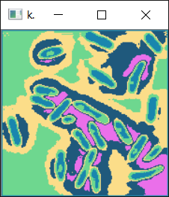

K=4 K=5

(b)Basic kmeans with grayscale and location

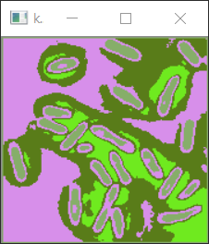 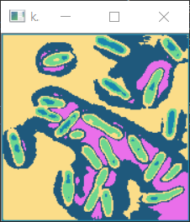

K=4 K=5

(c)Meng Hee Heng’s variant with grayscale

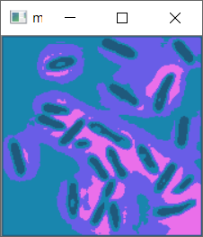 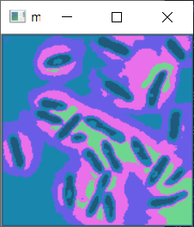

K=4 K=5

(d)Meng Hee Heng’s variant with grayscale and location

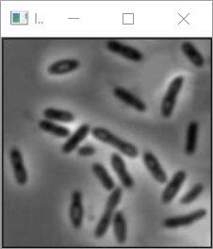 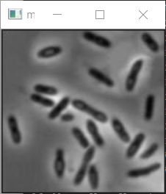

K=4 K=5

1. **discussion of results**

1. star.ppm and lena.ppm

By comparing the results of “star.ppm”, it can be found that in these methods, the segmentation effect is best when K=5. When K=4, the result of image segmentation is not detailed enough to separate the foreground and background colors. When K=6, the process over-processes the shadows in the background. The results of the four treatment methods mentioned above are basically the same.

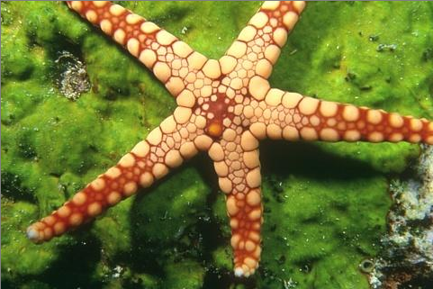Star.ppm original image.

star.ppm processed by basic kmeans with color(K=5)

The results of the “lena.ppm” demonstrate the similar effect comparing with the results above. When K=5, the segmentation between the different space within the image can be shown better than K=4 which lose some details on the body of the person in this picture, and similarly, when K=6, the image will be over processed. The technique of Men Hee Heng’s variant does not change a lot, either.

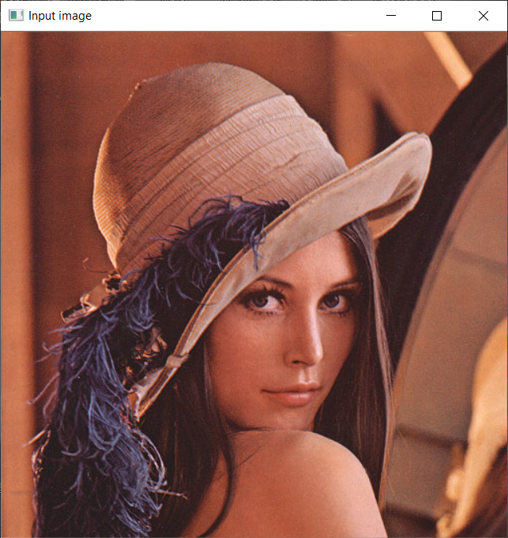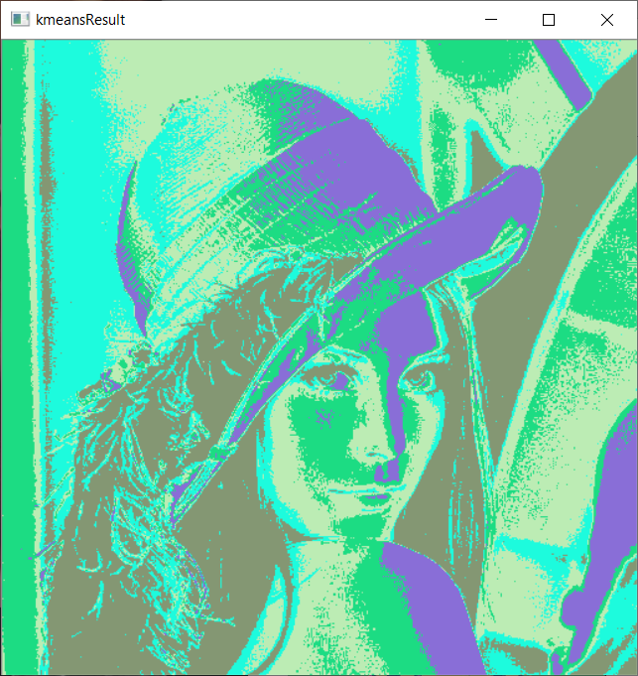

Original Basic kmeans with color(K=5)

2. brain.pgm

By comparison, brain.pgm is processed by (a) basic kmeans with grayscale or (b) basic kmeans with grayscale and location, and the result is best when K=4 is set.

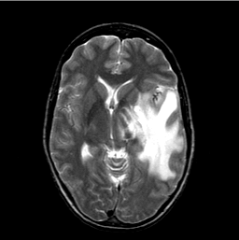

Original image and image processed by basic kmeans with grayscale (K=4)

The other two methods mentioned above, when K = 3 and K = 4, the results of the processing did not change.

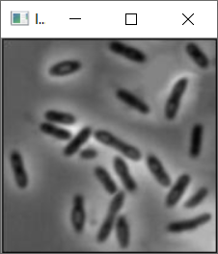 

Original image basic kmeans with grayscale (K=4)

The results on bacteria image also present that K=4 has the best effect.

1. **Extra results**

LBP results (examples):

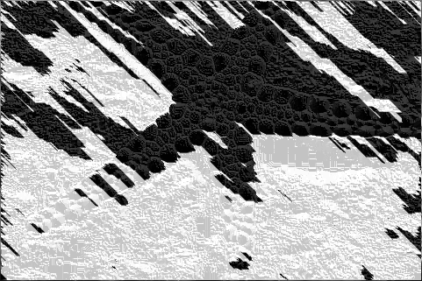 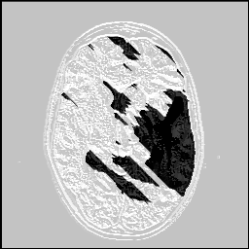 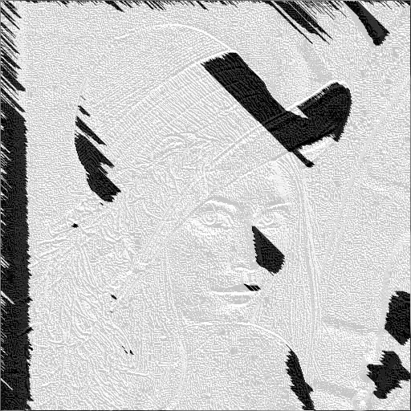 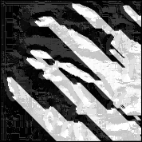

Law’s texture meaturement result(lena.ppm as example)

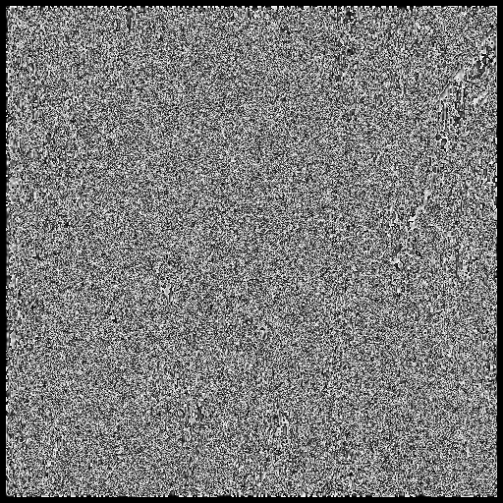 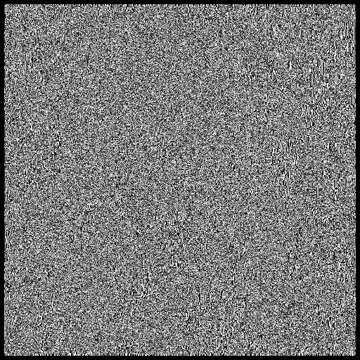 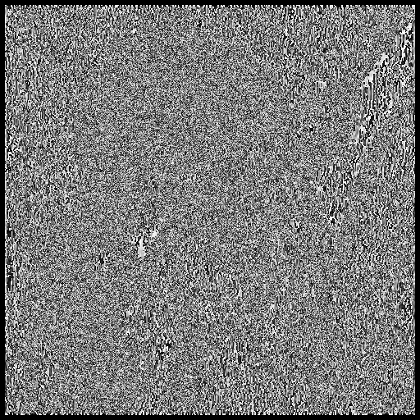

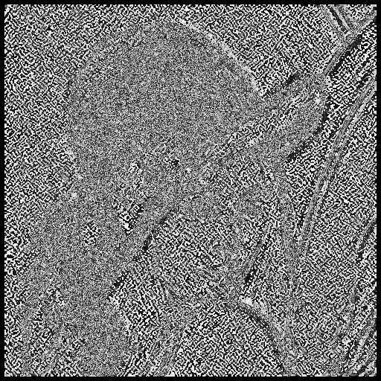 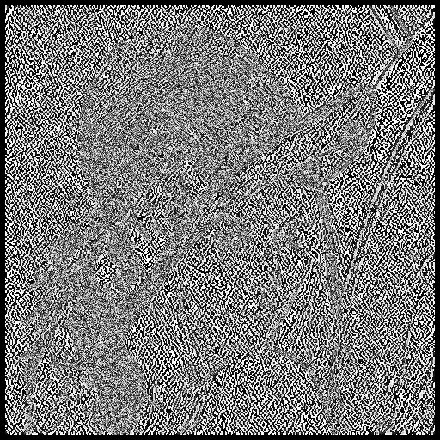 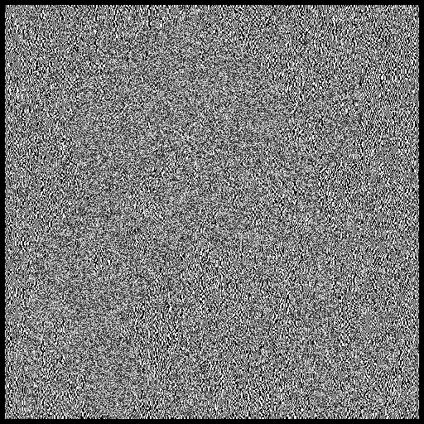

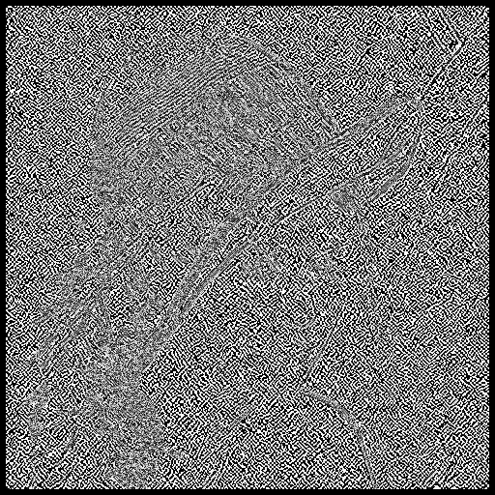 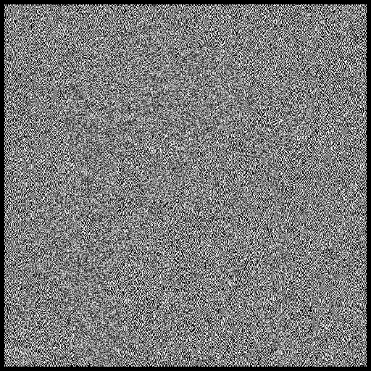 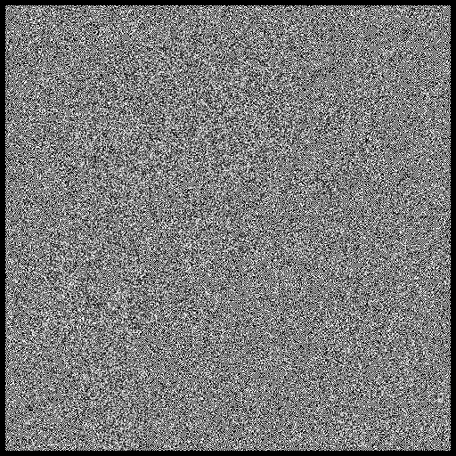

Preprocess image

